Handle Exception Task

**ASSESSMENT:**

**To create a dynamic and responsive website, where developers who are working on niche technologies can form a community and find answers for their queries.**

**You can refer to the below links as they can serve as a reference.**

[**https://www.geeksforgeeks.org/java/**](https://www.geeksforgeeks.org/java/)[**https://www.geeksforgeeks.org/python-programming-language/?ref=lbp**](https://www.geeksforgeeks.org/python-programming-language/?ref=lbp)

* Design a website that will give provision for users to write technical documents
* Client panel for reading the content
* The client panel with login will provide the option to add new content
* Input content after successful login and show it in the client screen for reading.
* Expectations – Content formatting, data input, and easy-to-input and reading.
* We need left side menu section -> which is dynamic in nature

**PROBLEM STATEMENT:**

Developers working on niche technologies face difficulties in finding dedicated communities or platforms where they can collaborate, share knowledge, and seek assistance for their specific areas of interest. Existing general-purpose platforms may not cater to the unique needs and challenges of these niche domains, resulting in a fragmented and inefficient exchange of information.

**OUTPUTS:**

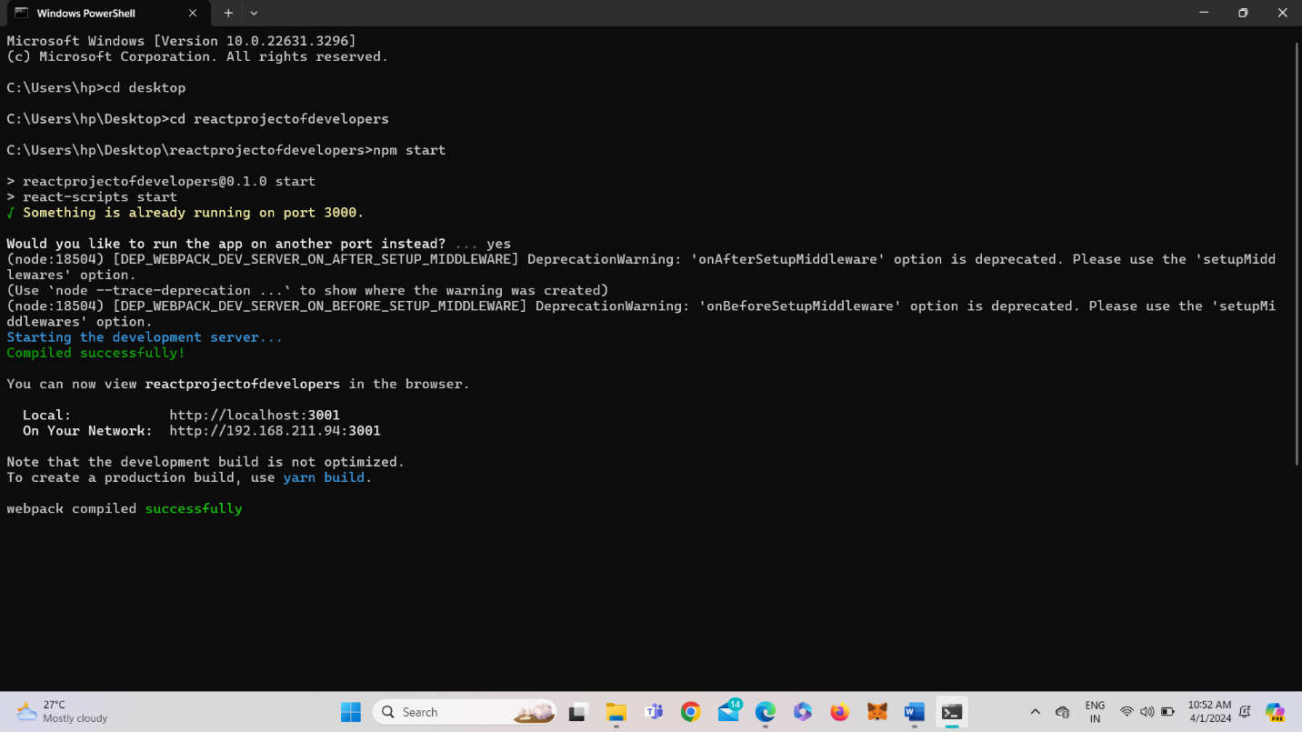

**Fig 1 : To begin running the server**

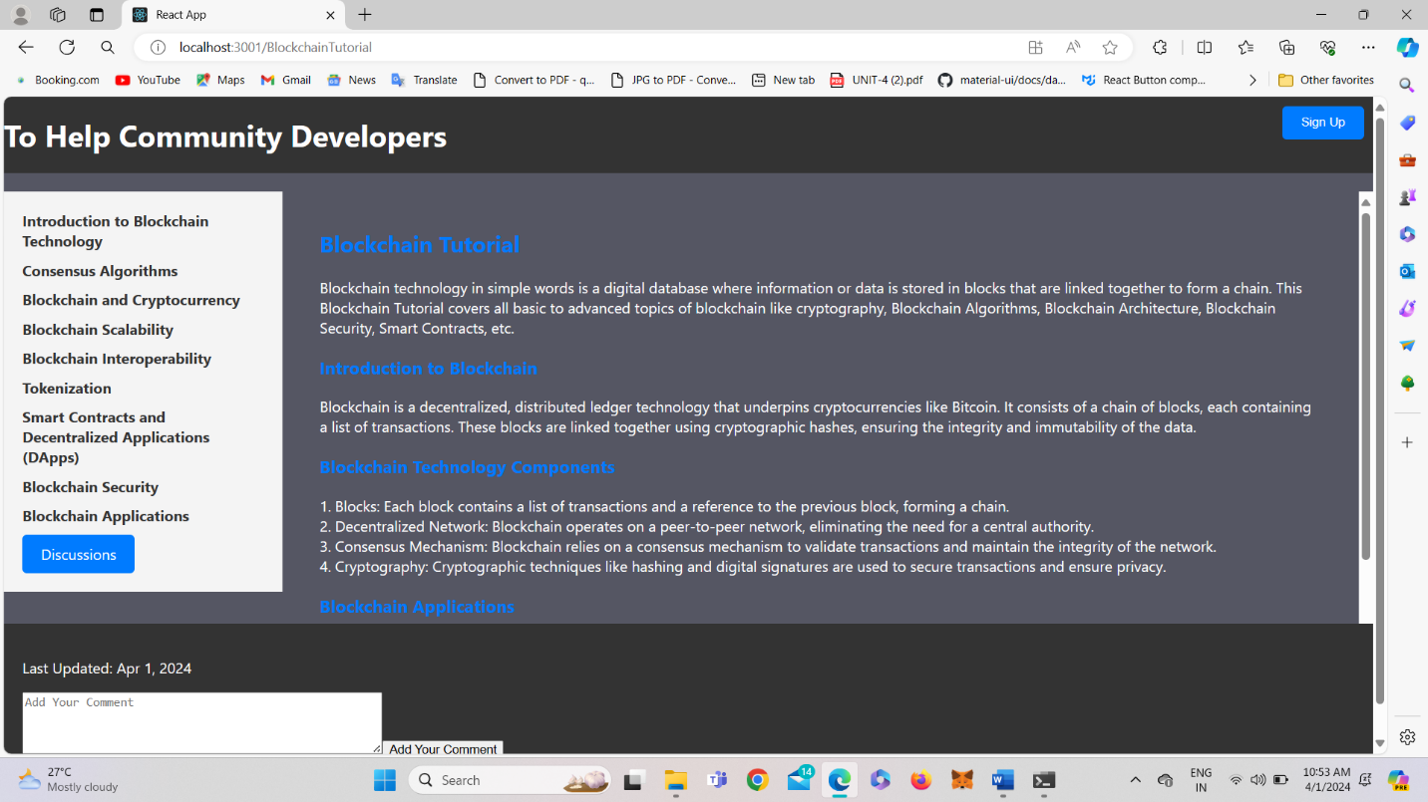

**Fig 2: The Content in LeftMenuHeader will be displayed when clicked on Introduction to Blockchain Technology**

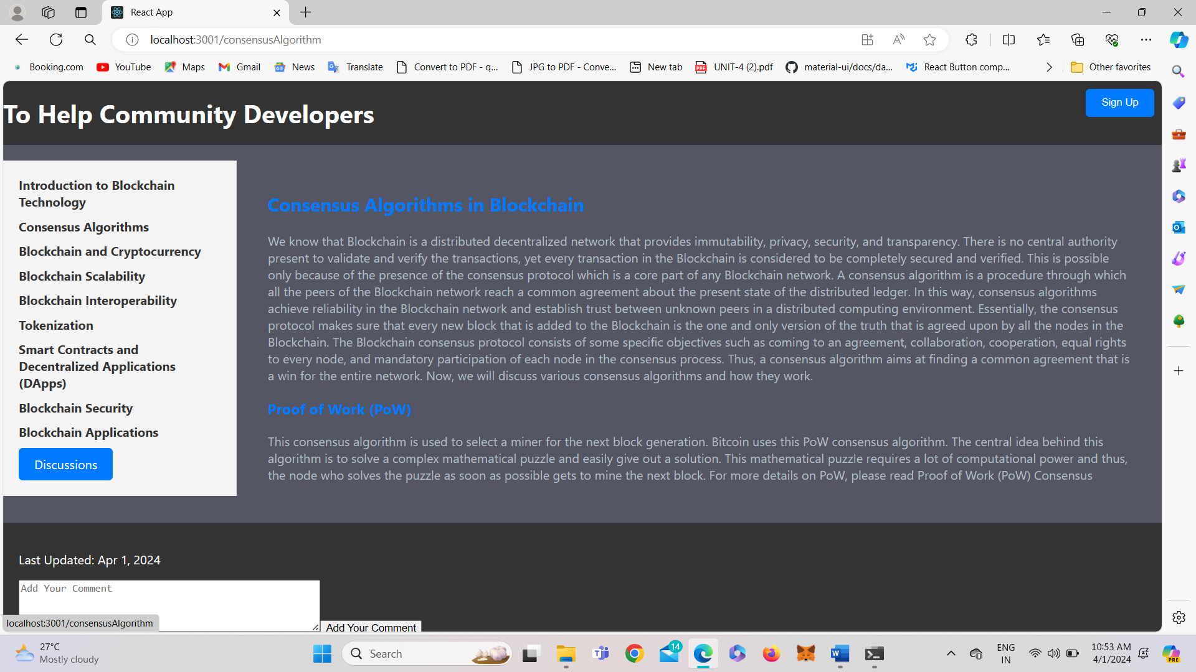

**Fig 3: When Clicked on Consensus Algorithm**

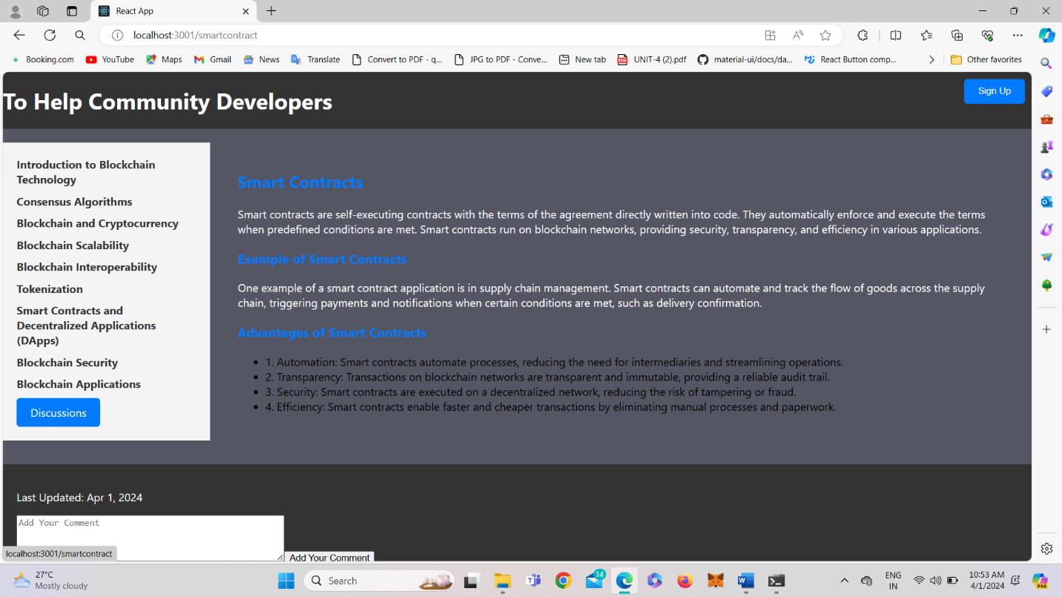

**Fig 4: When Clicked on Blockchain and Cryptocurrency**

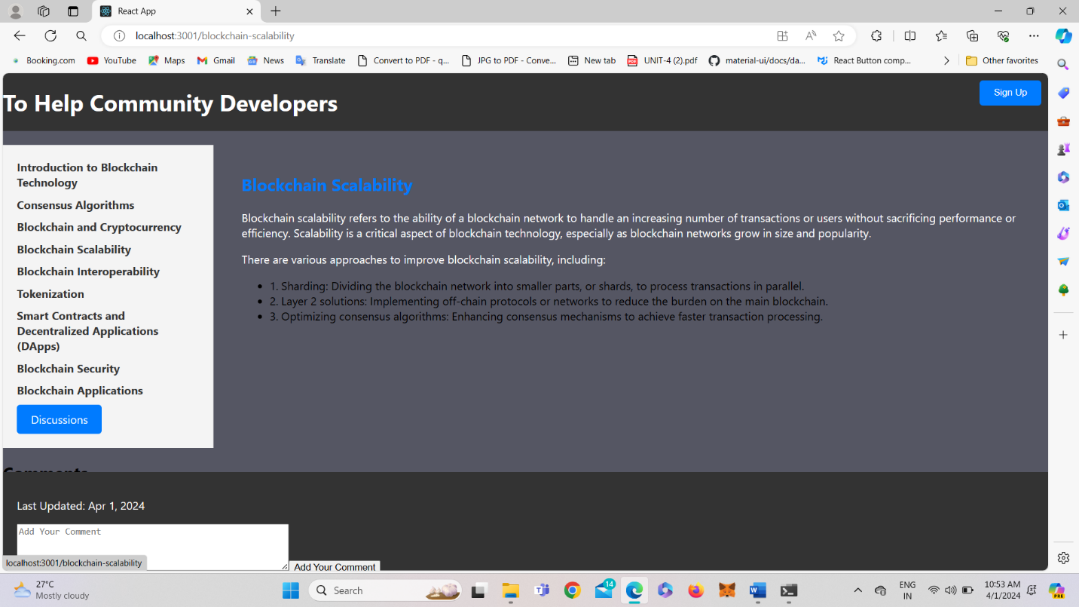

**Fig 5: When Clicked on Blockchain Scalability**

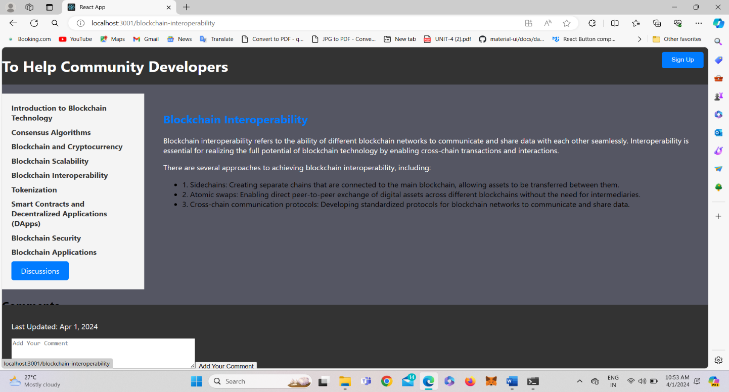

**Fig 6: When Clicked on Blockchain interoperability**

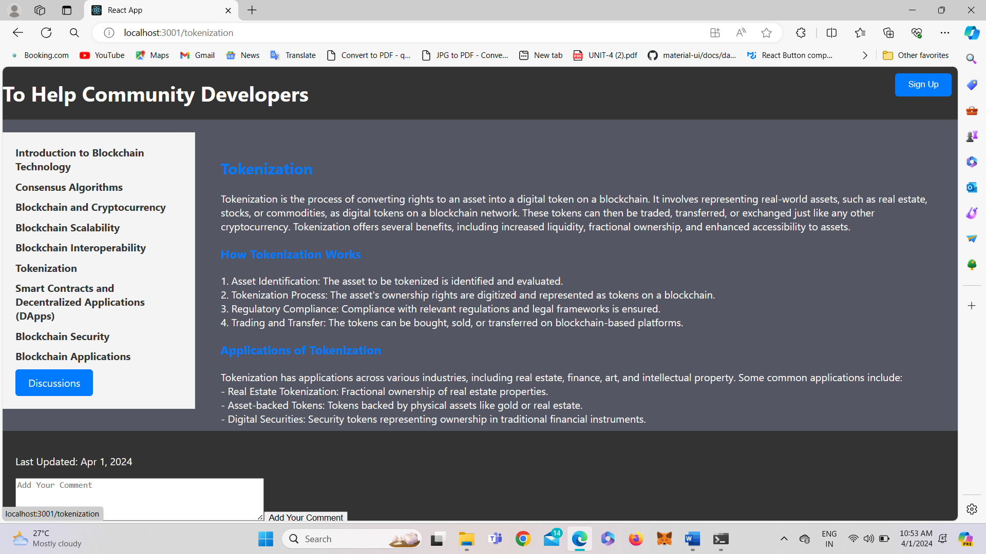

**Fig 7: When Clicked on Tokenization**

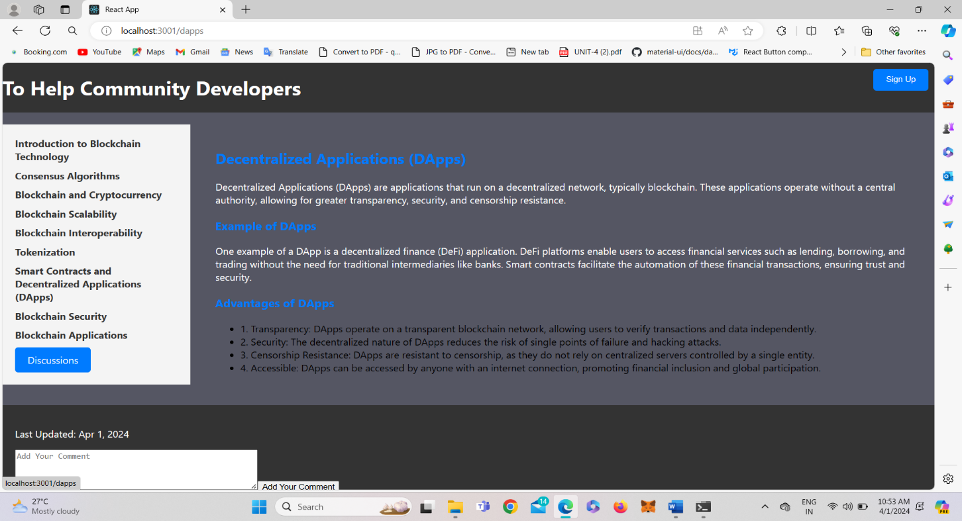

**Fig 8: When Clicked on Dapps**

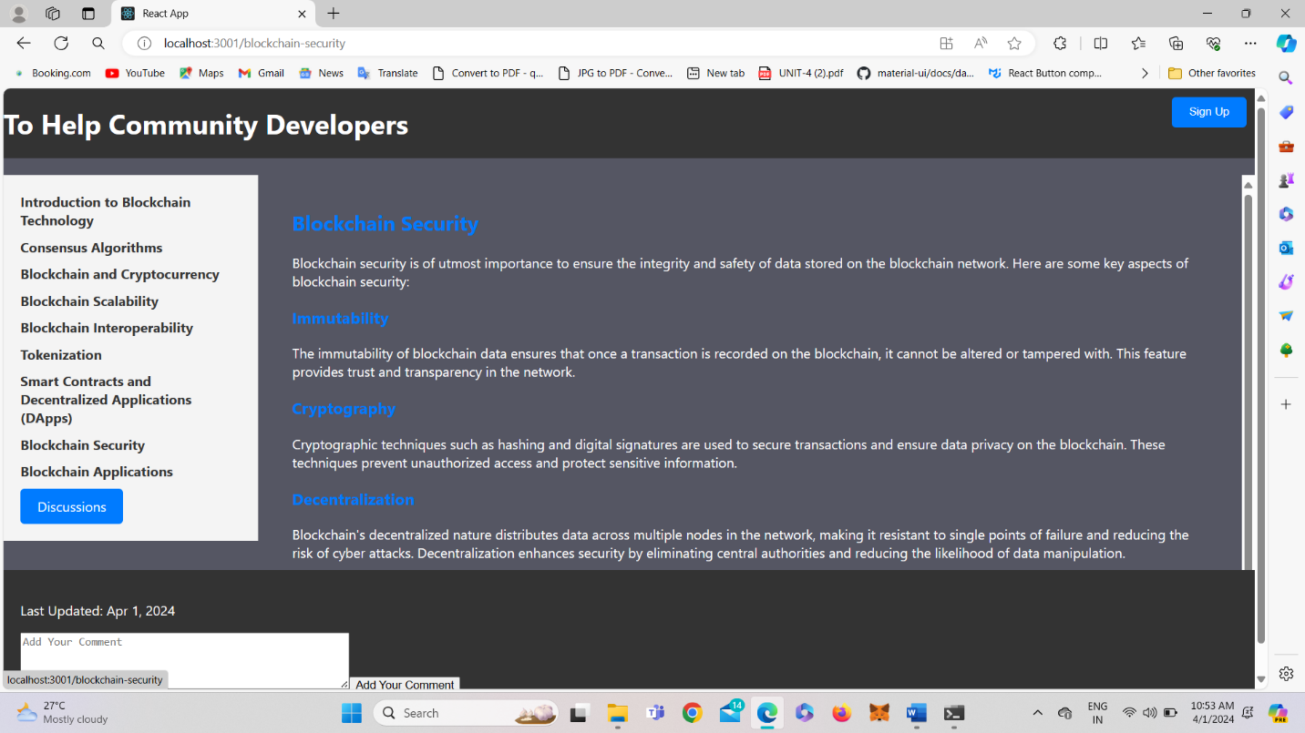

**Fig 9: When Clicked on Blockchain Security**

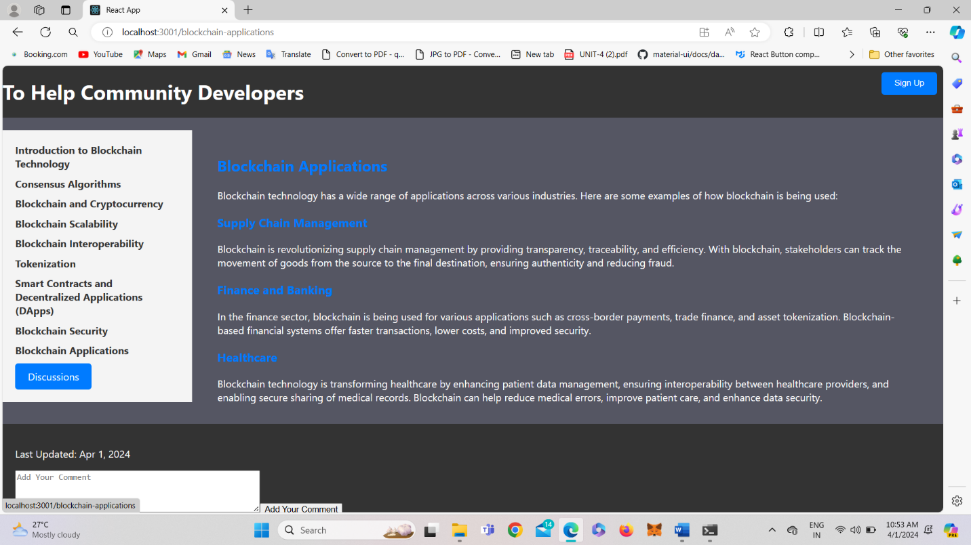

**Fig 10: When Clicked on Blockchain Applications**



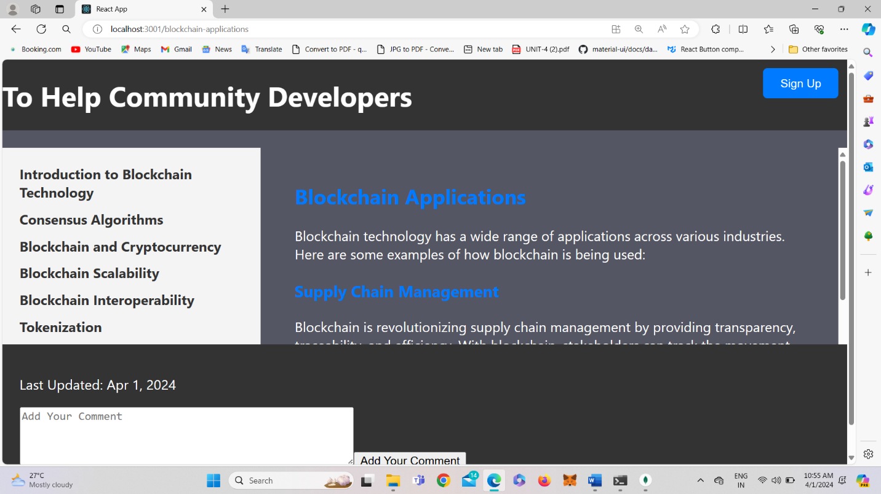



**Fig 11: SignUp Button**

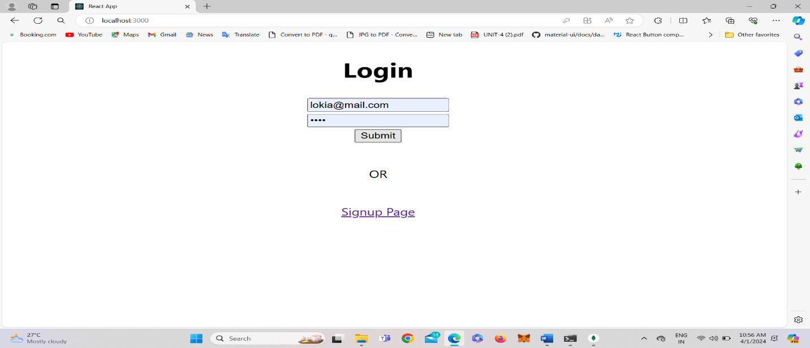

**Fig 12: Login Form**

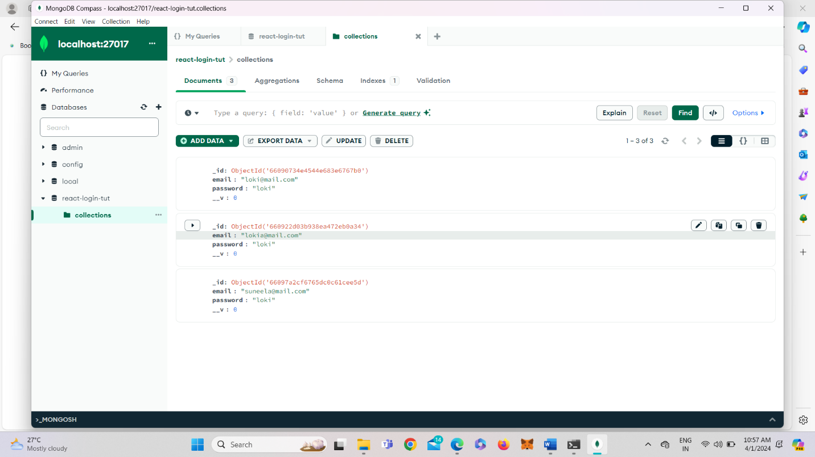

**Fig 13: The EmailId and Password from the form will be added into the mongodb database**

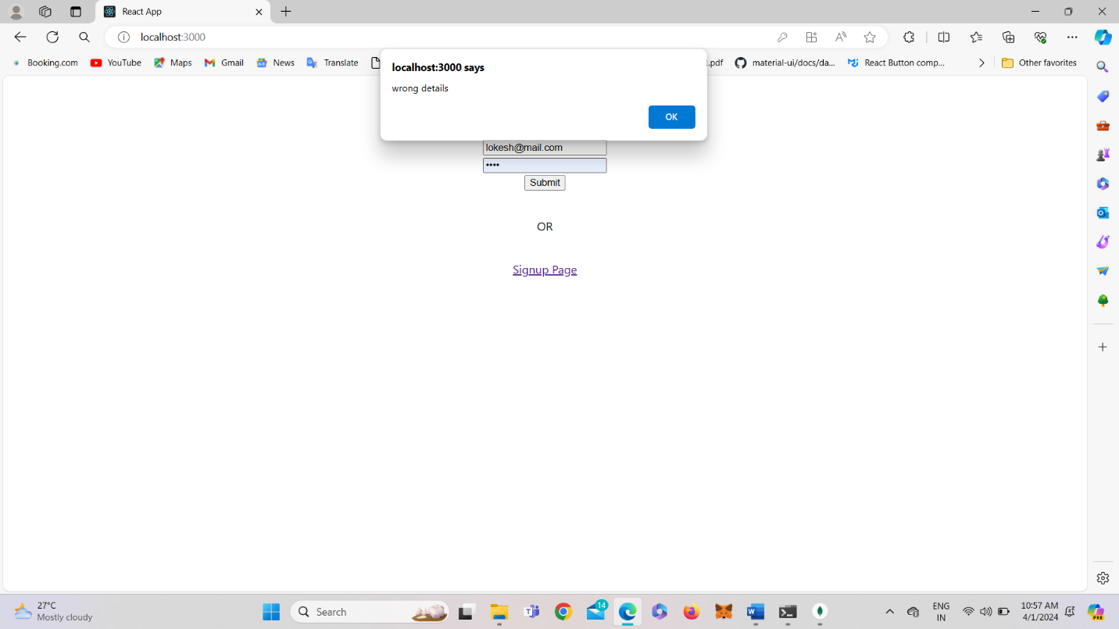

**Fig 14: If the EmailId and Password entered are not in Database it will prompt the alert message**

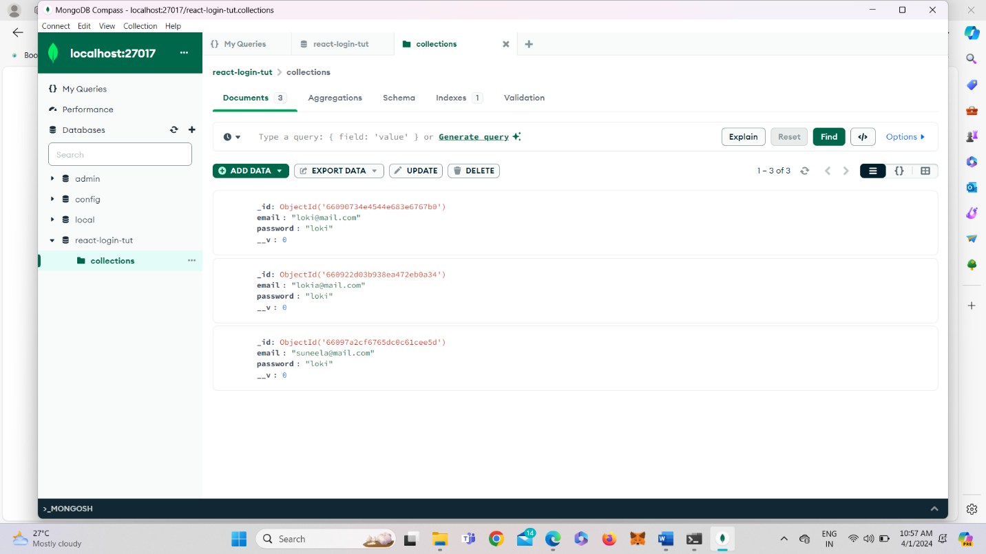

**Fig 15: The MongoDB**

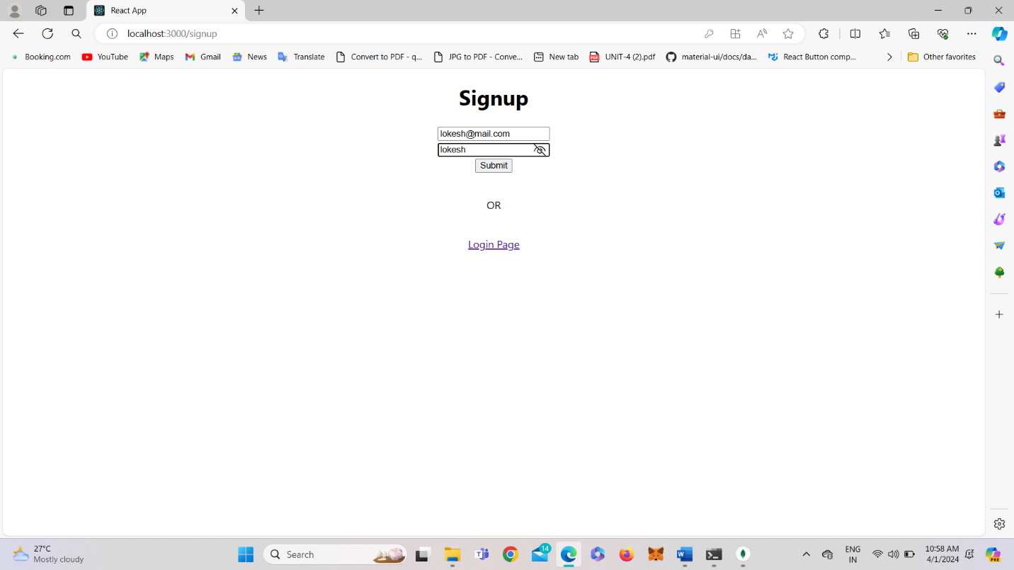

**Fig 16: SignUp form**

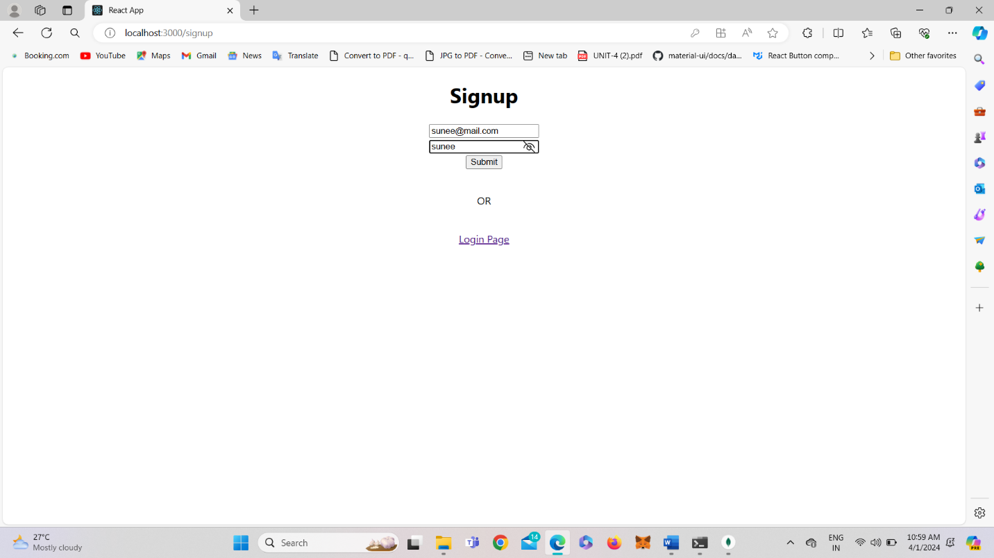

**Fig 17: When Clicked on Blockchain and Cryptocurrency**

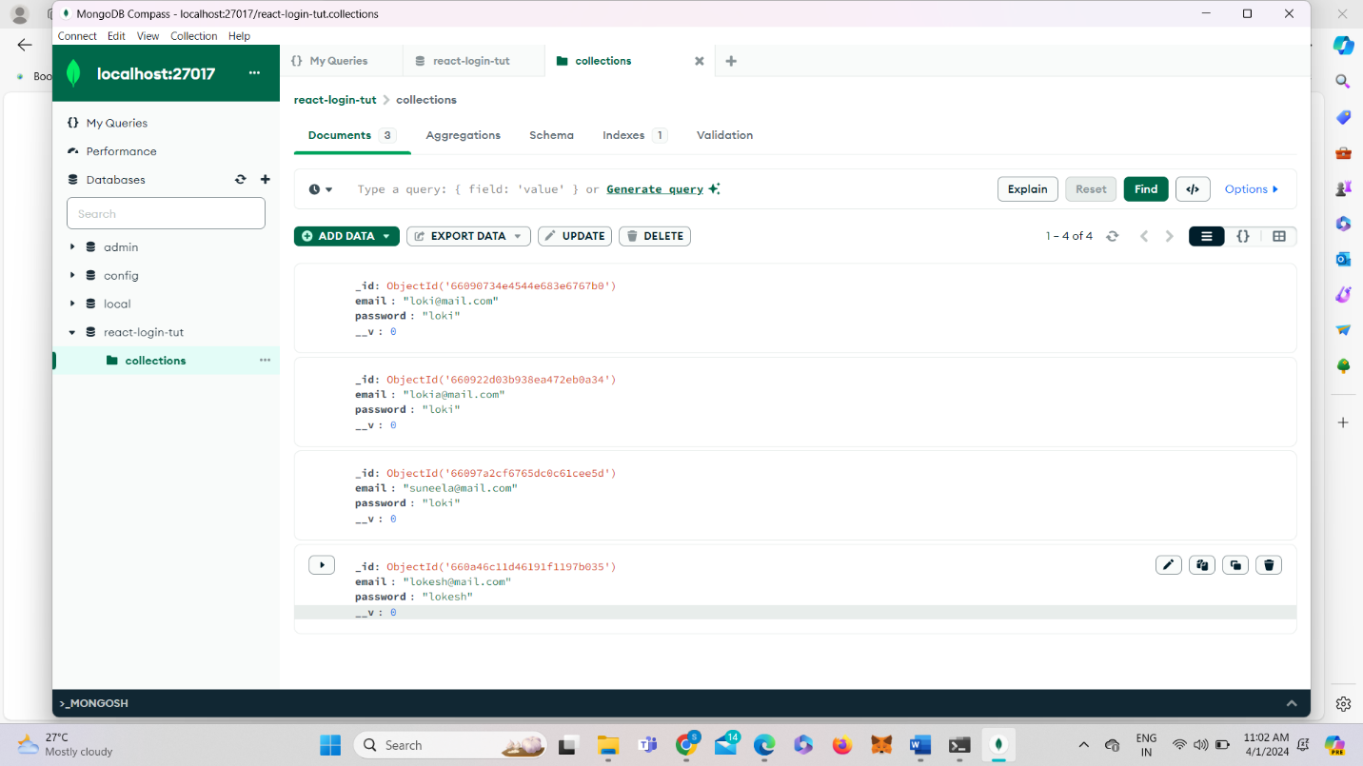

**Fig 18: Mongodb**

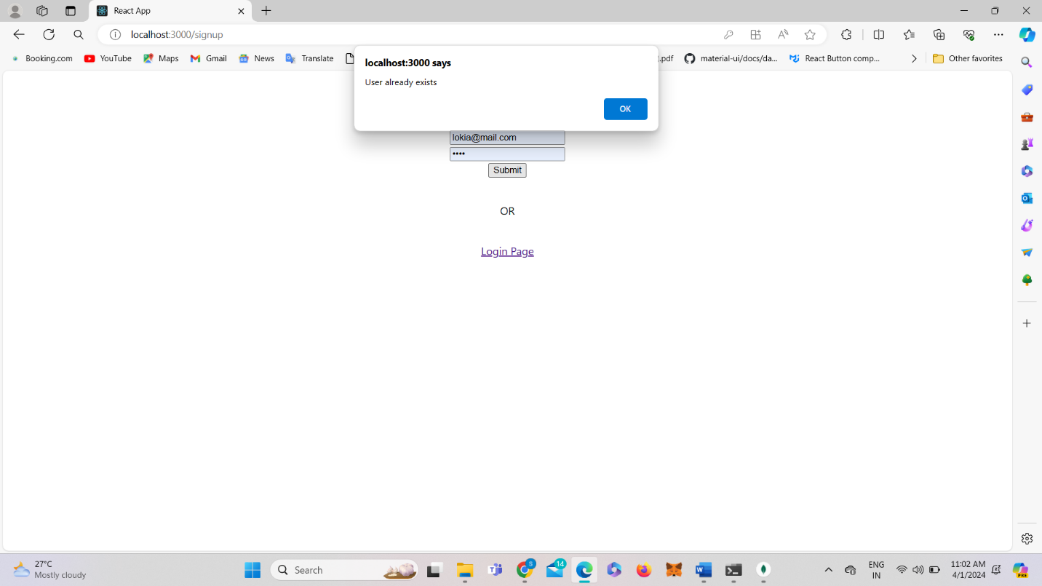

**Fig 20: When we try to insert the user that already exist**

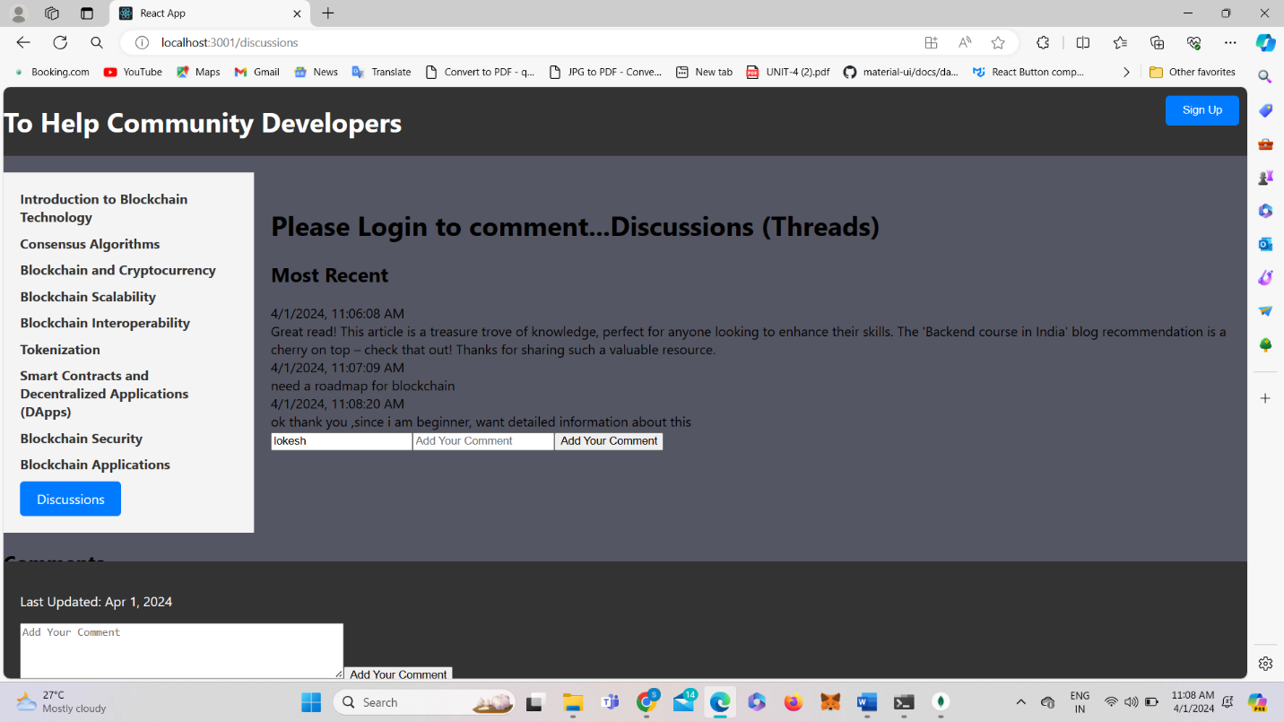

**Fig 21: Discussions**

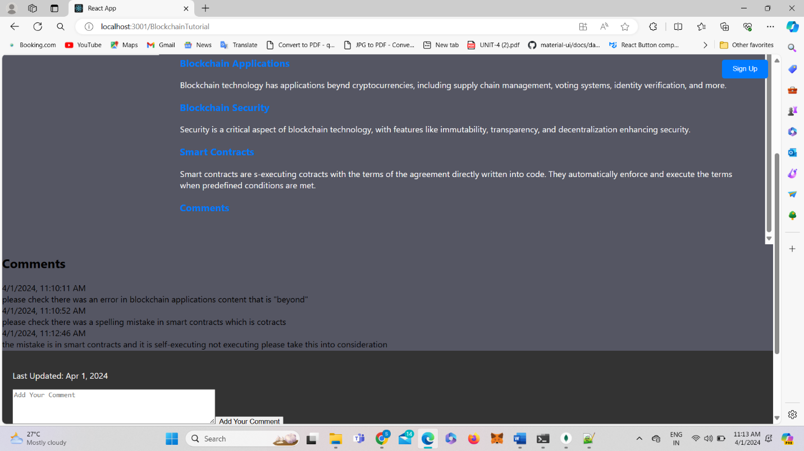

**Fig 22: Updation that to be done**

GITHUB LINK: